
HOUSE PRICE PREDICTION
A CAPSTONE PROJECT REPORT
Submitted in the partial fulfilment for the Course of
CSA1711 – ARTIFICIAL INTELLIGENCE
to the award of the degree of
BACHELOR OF TECHNOLOGY
IN
ARTIFICIAL INTELLIGENCE & DATA SCIENCE

Submitted by
GAUTHAM SINGH A P (192412007)

Under the Supervision of

DR. K. KRISHNAKUMAR

SIMATS ENGINEERING
Saveetha Institute of Medical and Technical Sciences
Chennai-602105
August 2025


SIMATS ENGINEERING
Saveetha Institute of Medical and Technical Sciences
Chennai-602105

DECLARATION

We, GAUTHAM SINGH A P (192412007) ECE Saveetha Institute of Medical and Technical Sciences, Saveetha University, Chennai, hereby declare that the Capstone Project Work entitled “HOUSE PRICE PREDICTION” is the result of our own bonafide efforts. To the best of our knowledge, the work presented herein is original, accurate, and has been carried out in accordance with principles of engineering ethics.

Place:
Date:

Signature of the Students with Names



SIMATS ENGINEERING
Saveetha Institute of Medical and Technical Sciences
Chennai-602105

BONAFIDE CERTIFICATE

This is to certify that the Capstone Project entitled has been carried out by GAUTHAM SINGH A P (192412007) under the supervision of DR. K. KRISHNAKUMAR and is submitted in partial fulfilment of the requirements for the current semester of the B. Tech AI & DS program at Saveetha Institute of Medical and Technical Sciences, Chennai.

SIGNATURE
SIGNATURE
(COURSE COORDINATOR)
DR. K. KRISHNAKUMAR
Professor
Computer Science Engineering
Saveetha School of Engineering
SIMATS

(COURSE FACULTY)
DR. K. KRISHNAKUMAR
Professor
Computer Science Engineering
Saveetha School of Engineering
SIMATS

Submitted for the Project work Viva-Voce held on __________________________________ .

INTERNAL EXAMINER EXTERNAL EXAMINER

ACKNOWLEDGEMENT

We would like to express our heartfelt gratitude to all those who supported and guided us throughout the successful completion of our Capstone Project. We are deeply thankful to our respected Founder and Chancellor, Dr. N.M. Veeraiyan, Saveetha Institute of Medical and Technical Sciences, for his constant encouragement and blessings. We also express our sincere thanks to our Pro-Chancellor, Dr. Deepak Nallaswamy Veeraiyan, and our Vice-Chancellor, Dr. S. Suresh Kumar, for their visionary leadership and moral support during the course of this project.

We are truly grateful to our Director, Dr. Ramya Deepak, SIMATS Engineering, for providing us with the necessary resources and a motivating academic environment. Our special thanks to our Principal, Dr. B. Ramesh for granting us access to the institute’s facilities and encouraging us throughout the process. We sincerely thank our Head of the Department,

We are especially indebted to our guide, DR. K. KRISHNAKUMAR for his creative suggestions, consistent feedback, and unwavering support during each stage of the project. We also express our gratitude to the Project Coordinators, Review Panel Members (Internal and External), and the entire faculty team for their constructive feedback and valuable inputs that helped improve the quality of our work. Finally, we thank all faculty members, lab technicians, our parents, and friends for their continuous encouragement and support.

Signature With Student Name
GAUTHAM SINGH A P (192412007)

INDIVIDUAL CONTRIBUTION STATEMENT
(Module 1 Evidence for Team Project)
Student / Register No. | Specific Responsibilities | Design & Development Contribution | Testing & Analysis Contribution | Report Contribution | Approx. Contribution
GAUTHAM SINGH A P  192412007 | Module 1: Dataset Preparation & Organization. | Dataset Preparation & Organization: Sourced the Bengaluru House Price dataset and cleaned it into 7,201 usable records, handling missing values and encoding categorical features for model training.handoff to Module 2. | Evaluated the trained Linear Regression model on an 80/20 holdout split, achieving an R² of 0.74 and MAE of ₹21.4 Lakh, and validated prediction behavior across varied input combinations (locality, sqft, BHK, bath, balcony) to confirm outputs stayed realistic and consistent. | Documented Module 1 design, implementation, testing, risks, results, conclusion and reflection. | 100% of Module 1 scope documented in this report

Note: The percentage above refers only to the individual Module 1 scope documented in this report; it is not a claim of 100% contribution to the complete two-module team project.

ABSTRACT
Accurate estimation of residential property value is a persistent challenge for buyers, sellers, and financial institutions, particularly in rapidly growing urban markets where prices vary sharply across localities. This project presents an AI-based approach to house price prediction using structured housing data, applied to the Bengaluru real estate market. A dataset of 13,320 property listings, comprising features such as total area, number of bedrooms (BHK), bathrooms, balconies, area type, and locality, was cleaned and preprocessed to yield 7,201 usable records. A Linear Regression model was trained on this data to learn the relationship between property attributes and market price, achieving a holdout R² of 0.743 and a mean absolute error of approximately Rs 21.43 Lakh. The learned model was deployed as an interactive desktop application that allows users to input property characteristics and instantly receive a predicted price along with a transparent breakdown of each feature's contribution to the final estimate. The results demonstrate that even a relatively simple, interpretable model can capture meaningful pricing patterns from structured housing data, offering a practical, explainable tool for preliminary property valuation while highlighting the influence of locality and area-type premiums on price outcomes.

TABLE OF CONTENTS
Sl. No. | Title | Page No.
i | BONAFIDE CERTIFICATE | 2
ii | DECLARATION | 3
iii | INDIVIDUAL CONTRIBUTION STATEMENT | 4
iv | ABSTRACT | 5
vi | LIST OF TABLES/FIGURES | 8
1 | CHAPTER 1: Introduction and Engineering Problem | 9
2 | CHAPTER 2: Literature Review and Existing Solutions | 12
3 | CHAPTER 3: Engineering Design & Trade-offs, Sustainability, Ethics, Safety, Risk & Security | 14
4 | CHAPTER 4: Implementation, Testing & Results, Project Management | 19
5 | CHAPTER 5: Conclusion, Future Work and Reflection | 28
 | References | 30
 | Appendices | 31

LIST OF TABLES
Table No. | Table Name | Page No.
3.1 | Stakeholder / User Requirements | 14
3.2 | Functional and Non-Functional Requirements | 14
3.3 | Applicable Standards and Constraints | 15
3.4 | Design Specifications | 15
3.5 | Alternative Solution Evaluation Matrix | 16
3.6 | Trade-off Analysis | 17
3.7 | Sustainability, Ethics, Safety and Security | 18
3.8 | Risk Register | 18
4.1 | Development Resources and Modern Tools | 19
4.2 | Module 1 Test Plan | 22
4.3 | Verification Summary | 23
4.4 | Achievement of Objectives | 24
4.5 | Module 1 Milestones | 26
4.6 | Individual Role and Contribution | 26
4.7 | Incremental Project Cost | 26
Figure No. | Figure Name | Page No.
3.1 | Module 1 System Architecture | 17
3.2 | Traffic Frame Preprocessing and Data Preparation Flow | 17
4.1 | Module 1 CCTV Frame Collection and Preprocessing Example | 22

Chapter 1: Introduction
Residential real estate is one of the largest and most consequential financial decisions individuals make, yet determining a fair and accurate price for a property remains a fundamentally difficult problem. Traditional valuation relies heavily on manual appraisal, broker judgment, and comparison with a handful of similar recent sales — a process that is time-consuming, inconsistent across appraisers, and often opaque to the buyer or seller. As cities expand and real estate markets grow more complex, with prices influenced by dozens of interacting factors such as locality, property size, configuration, and build quality, the limitations of manual estimation become more pronounced.
With the increasing availability of structured housing datasets — records containing attributes like area, number of bedrooms, bathrooms, locality, and property type — machine learning offers a data-driven alternative to conventional appraisal. Rather than relying on a small set of comparable properties, a trained model can learn pricing patterns from thousands of historical transactions simultaneously, capturing relationships that may not be obvious through manual inspection. This project explores such an approach, using the Bengaluru housing market as a case study, to build a system that predicts residential property value directly from structured data and presents that prediction in an interpretable, usable form.
2. Engineering Problem
The core engineering problem addressed in this project is: given structured attributes of a residential property, how can a model reliably and transparently estimate its market price?
This problem breaks down into several concrete sub-challenges:
Data quality and inconsistency: Raw housing data is often noisy — inconsistent locality naming, missing values, outlier listings, and non-numeric fields (e.g., "2 BHK", "1200 sqft" ranges) that must be cleaned and standardized before they can be used for training.
High-cardinality categorical features: Locality is a critical price driver but takes on dozens of distinct values, many with very few listings, requiring careful encoding (e.g., grouping rare localities) to avoid overfitting.
Feature interdependence: Attributes such as area, BHK, and bathroom count are correlated with one another, which can distort a model's learned coefficients (multicollinearity) and make individual feature contributions harder to interpret correctly.
Balancing accuracy with interpretability: A price prediction is only useful if end users can trust and understand it. This creates an engineering trade-off between using complex models that may fit the data more closely and simpler, interpretable models whose predictions can be explained feature-by-feature.
Deployment and usability: A trained model is of limited value if it isn't accessible. The system must be packaged into a usable interface that non-technical users — such as a homebuyer or seller — can interact with directly, without needing to run code or understand the underlying model.
Addressing these challenges requires an end-to-end pipeline: data cleaning and preprocessing, feature engineering, model training and validation, and finally deployment through an interactive application — which together form the scope of this project.

Chapter 2: Problem Identification and Analysis
Manual and heuristic-based property valuation methods suffer from several well-documented shortcomings that motivate the need for a data-driven solution:

Subjectivity in appraisal: Two appraisers evaluating the same property can arrive at noticeably different valuations, since judgments about "comparable" properties and locality desirability are inherently subjective.
Limited comparables: Manual estimation typically relies on a small number of recently sold, similar properties. In markets with high locality-level price variation, this small sample size can produce misleading estimates.
Inability to scale: Manual valuation does not scale efficiently when a large number of listings need to be priced quickly, such as for a real estate platform or bulk portfolio assessment.
Opacity to end users: Buyers and sellers are often given a final number with little visibility into why a property is priced the way it is, making it difficult to negotiate or sanity-check the estimate.
These shortcomings define the practical need this project addresses: an automated, data-driven, and explainable method for estimating residential property value.

2.2 Analysis of Contributing Factors
To design an effective solution, the raw housing dataset was analyzed to identify which structured attributes most strongly influence price:

Factor | Nature of Influence | Analytical Challenge
Locality | Strong, non-linear price premium/discount per area | High-cardinality categorical variable; many localities have sparse data
Total area (sq ft) | Generally positive, near-linear relationship with price | Wide range and presence of outlier/erroneous entries
BHK (bedrooms) | Correlated with area; not independently predictive | Multicollinearity with sqft and bathroom count
Bathrooms | Weak positive signal, but correlated with BHK/area | Same multicollinearity concern as BHK
Balconies | Minor influence | Sparse variation, weak individual signal
Area type | Reflects build/finish quality | Categorical, unevenly distributed across listings
This analysis revealed two central technical difficulties that shaped the modeling approach:

Multicollinearity among size-related features (sqft, BHK, bathrooms, balconies) — since these variables move together, a model can assign counterintuitive weights to individual features (e.g., a negative BHK coefficient) even when the combined effect of size on price is strongly positive. This is a statistical artifact rather than a genuine negative relationship, and needed to be explicitly understood and documented rather than "fixed" artificially.
High-cardinality locality encoding — with dozens of distinct localities, many represented by only a handful of listings, rare localities were grouped into an "Other Bangalore" reference category to prevent the model from overfitting to small, unreliable samples.
2.3 Problem Framing
Based on this analysis, the prediction task was framed as a supervised regression problem: given a feature vector x (area, BHK, bathrooms, balconies, locality, area type), learn a function f(x) that estimates the continuous target variable — property price in Rs Lakh — while remaining interpretable enough to expose why a given prediction was made. This framing directly informed the choice of a linear model as a first, interpretable baseline, with model complexity/accuracy trade-offs to be explored as the project develops..

Chapter 3: Solution Design and Implementation
The proposed solution is structured as an end-to-end pipeline consisting of four stages: data preprocessing, model training, prediction logic, and a user-facing application layer. This separation allows the model to be retrained independently of the interface, while the deployed application remains lightweight and dependency-free for end users.
Raw Dataset (CSV) → Data Cleaning & Feature Engineering → Model Training
→ Trained Coefficients (embedded) → Prediction Engine → GUI Application
3.2 Data Preprocessing and Feature Engineering
The raw dataset (13,320 listings) was cleaned to produce 7,201 usable records through the following steps:
Handling inconsistent formats: Fields such as total_sqft (which sometimes contained ranges like "1200–1400") were parsed into single numeric values; non-numeric or unparseable entries were dropped.
Deriving numeric features: The size column (e.g., "2 BHK", "3 Bedroom") was parsed to extract a numeric BHK value.
Outlier removal: Listings with implausible values (e.g., extremely low price-per-sqft, or bathroom counts exceeding BHK by an unrealistic margin) were filtered out to reduce noise.
Handling missing values: Rows with missing critical fields (location, size, total_sqft, price) were removed rather than imputed, to avoid introducing artificial patterns into a relatively small dataset.
Categorical grouping: Localities with very few listings were grouped into a single "Other Bangalore" category, reducing the location feature from an unmanageable number of sparse categories to 29 meaningful levels plus a fallback.
Encoding: location and area_type were one-hot encoded, with the most frequent category in each (Other Bangalore, Super built-up Area) set as the reference level to keep the coefficient count manageable and interpretable.

3.3 Model Training

Algorithm: Linear Regression (scikit-learn), chosen as an interpretable baseline where each feature's contribution to price can be read directly from its coefficient.
Feature set: total_sqft, bath, bhk, balcony, one-hot encoded location (29 levels), one-hot encoded area_type (3 levels vs. reference) — 37 learned parameters in total (36 weights + 1 intercept).
Train/test split: 80/20 split of the cleaned 7,201-row dataset.
Evaluation metrics: Holdout R² = 0.743 and Mean Absolute Error (MAE) = Rs 21.43 Lakh, indicating the model explains roughly 74% of price variance on unseen data, with typical prediction error within ~21 Lakh.

3.4 Prediction Engine
Rather than requiring the trained scikit-learn model object at runtime, the learned coefficients were extracted and embedded directly into the application as a lightweight dictionary (MODEL). The predict() function reconstructs the linear regression formula manually:
price = intercept + (sqft_coef × sqft) + (bath_coef × bath) + (bhk_coef × bhk)
+ (balcony_coef × balcony) + location_coef + area_type_coef
A price floor (minimum Rs 8 Lakh) guards against unrealistic negative outputs for extreme input combinations. The function also returns a breakdown dictionary, decomposing the final prediction into each feature's individual contribution — this is what powers the transparency/interpretability goal identified in the problem analysis.

3.5 Application Layer
The prediction engine is wrapped in a Tkinter-based desktop GUI, chosen specifically so the application requires no external dependencies to run (Tkinter ships with standard Python). Key implementation elements:

Input controls: A locality dropdown, sliders for sqft/BHK/bathrooms/balconies, and an area-type dropdown, each triggering live recalculation via bound event callbacks.
Real-time feedback: Every input change immediately recomputes and redisplays the predicted price, its confidence range (± holdout MAE), and the itemized contribution ledger.
Optional retraining path: A "Retrain from CSV" menu option allows advanced users with pandas/scikit-learn installed to regenerate the model from raw data, keeping the deployed app decoupled from the training environment.
Transparency by design: The "About this model" dialog surfaces dataset size, metrics, and known limitations (e.g., the multicollinearity-driven negative BHK/balcony coefficients) directly to the user, rather than hiding model caveats.

3.6 Design Rationale
The key implementation decision — embedding coefficients rather than shipping the trained model object — was made to prioritize portability and instant usability over retraining convenience, directly addressing the deployment/usability challenge identified during problem analysis, while the itemized breakdown addresses the opacity concern raised for traditional valuation methods..

Chapter 4: Results and Recommendations
The trained Linear Regression model was evaluated on a held-out 20% test split (approximately 1,440 records) drawn from the cleaned dataset of 7,201 listings.

Metric | Value | Interpretation
Holdout R² | 0.743 | The model explains ~74.3% of the variance in property prices on unseen data
Holdout MAE | Rs 21.43 Lakh | On average, predictions deviate from actual price by ~21.43 Lakh
Learned parameters | 37 (36 weights + 1 intercept) | Reflects 4 numeric features + 29 locality levels + 3 area-type levels
Training data | 7,201 rows (cleaned from 13,320 raw) | ~46% of raw listings were removed during cleaning/outlier filtering

Qualitative observations from the model's learned coefficients:

Locality dominates price variation. Coefficients ranged from roughly -32 Lakh (Begur Road) to +144 Lakh (Rajaji Nagar) relative to the reference category, confirming that where a property is located contributes more to price than any single structural attribute.
Area (sqft) shows a stable, intuitive positive relationship with price, consistent with expectations and providing a reliable base signal for the model.
BHK and balcony count showed counterintuitive negative coefficients once sqft and bathrooms were held constant — a multicollinearity artifact rather than a genuine negative effect, since these features move together with area in the raw data. This was documented transparently in the application rather than corrected artificially, preserving model honesty over surface-level "clean" output.
Area type contributed a modest premium/discount (e.g., Plot Area: +13.6 Lakh, Built-up Area: -1.6 Lakh relative to Super built-up Area), consistent with it acting as a proxy for build/finish quality.
The application successfully translated these results into an interpretable tool, giving users a real-time price estimate alongside a transparent, feature-by-feature breakdown — directly satisfying the interpretability goal set out in the problem analysis.

4.2 Limitations

An R² of 0.743 leaves roughly 26% of price variance unexplained, likely due to unmodeled factors such as property age, floor number, amenities, exact address, and market timing — none of which are present in the dataset.
A single linear model cannot capture non-linear pricing effects (e.g., diminishing returns on very large properties, or non-linear locality-sqft interactions).
~46% of raw data was discarded during cleaning, which improves data quality but also reduces the effective sample the model learns from.
The multicollinearity among size-related features makes individual BHK/bathroom/balcony coefficients unreliable in isolation, even though the model's overall predictions remain sound.

4.3 Recommendations

- Benchmark against non-linear models (e.g., Random Forest, Gradient Boosting/LightGBM, or an ensemble) to quantify how much accuracy is left on the table by using a linear baseline, while retaining Linear Regression as the interpretable reference point.
- Address multicollinearity explicitly — e.g., using regularization (Ridge/Lasso) or deriving a composite "size score" from sqft/BHK/bathrooms — to produce more stable, individually meaningful coefficients.
- Enrich the feature set where possible with additional structured attributes (property age, floor, amenities) to reduce unexplained variance.
- Introduce cross-validation rather than a single 80/20 split to obtain a more robust estimate of generalization performance.
- Extend interpretability tooling, e.g., by adding confidence intervals per prediction (rather than a single global MAE-based range) so uncertainty scales appropriately with how well-represented a given locality/property type is in the training data.
- Consider periodic retraining as new listings become available, since real estate prices drift over time and a static embedded model will gradually go stale..

Chapter 5: Reflection on Learning and Personal Development
Working on this project deepened my understanding of what it actually takes to move a machine learning idea from a dataset to a usable, working tool — a process that turned out to be far less linear than I initially expected.

Technical learning. Before this project, I understood regression largely as a mathematical concept. Applying it to a real, messy dataset taught me how much of a machine learning project's effort actually lies in data preparation rather than modeling itself — parsing inconsistent fields, handling outliers, and deciding how to group sparse categorical values like locality were far more time-consuming and consequential than fitting the model. I also gained a much more concrete understanding of multicollinearity: seeing a counterintuitive negative coefficient for BHK forced me to actually investigate why a model produces a result, rather than accepting or silently "fixing" it. That experience shifted how I think about model outputs — a coefficient is a statistical artifact of the data it was trained on, not automatically a causal truth, and communicating that distinction honestly is part of doing the work responsibly.
Engineering and design learning. Building the desktop application pushed me beyond model training into thinking about a model as a product. Deciding to embed the trained coefficients directly into the app, rather than shipping the full trained model object, was a small design choice that taught me a bigger lesson: usability constraints (zero-dependency install, instant startup) can and should shape technical decisions just as much as accuracy metrics do. I also learned the value of transparency in interface design — surfacing the model's limitations directly to the user (through the "About this model" dialog) rather than hiding them, which felt more aligned with responsible AI practice than simply presenting a confident number.
Process and personal development. This project reinforced a working style I've noticed in myself: I tend to move fastest and think most clearly when I have something concrete to react to — a script, a rough draft, a working prototype — rather than starting from pure theory. Building the app first and then working backward through the report structure (introduction, problem analysis, solution design) matched that instinct well, and made the writing process feel grounded rather than abstract. At the same time, writing the results and recommendations sections required me to step back and evaluate my own work critically rather than just presenting it favorably — identifying the model's real limitations (R² leaving over a quarter of variance unexplained, multicollinearity, data loss during cleaning) was a useful exercise in intellectual honesty that I want to carry into future projects.
Looking ahead. This project has also clarified what I want to explore next — comparing the linear baseline against non-linear ensemble methods, and getting more rigorous about validation through cross-validation rather than a single train/test split. More broadly, it reinforced that I find the most value in projects that combine a genuine modeling problem with a real, usable output, rather than treating the two as separate exercises..

Chapter 6: Conclusion
This project set out to address a practical engineering problem: how to estimate residential property value reliably and transparently from structured housing data, without relying on subjective, hard-to-scale manual appraisal. Using the Bengaluru housing dataset as a case study, an end-to-end pipeline was built — spanning data cleaning, feature engineering, model training, and deployment through an interactive desktop application — that takes raw property listings and turns them into an interpretable, real-time price estimation tool.

The Linear Regression model, while intentionally simple, proved to be an effective and honest baseline. It achieved a holdout R² of 0.743 and an MAE of Rs 21.43 Lakh, correctly identified locality as the dominant driver of price, and — importantly — surfaced its own limitations (such as multicollinearity-driven coefficients) rather than concealing them. This aligns directly with the project's original goal: not just to predict a price, but to do so in a way users can understand and trust.

The resulting application demonstrates that a data-driven approach can meaningfully improve on manual valuation in terms of consistency, scalability, and transparency, while also making clear that this is a first step rather than a finished solution. Roughly a quarter of price variance remains unexplained, and the recommendations outlined — benchmarking non-linear models, addressing multicollinearity, enriching the feature set, and adopting cross-validation — define a concrete path toward a more accurate and robust system.

More broadly, this project illustrates how an AI-based approach to house price prediction can bridge the gap between raw structured data and a practical decision-support tool, offering a foundation that can be iteratively strengthened as more data, more sophisticated models, and more rigorous validation are incorporated..

References
- Amitabh Ajoy. Bengaluru House Price Data. Kaggle. Available at: https://www.kaggle.com/datasets/amitabhajoy/bengaluru-house-price-data
- Pedregosa, F., Varoquaux, G., Gramfort, A., et al. (2011). Scikit-learn: Machine Learning in Python. Journal of Machine Learning Research, 12, 2825–2830.
- Python Software Foundation. Tkinter — Python interface to Tcl/Tk. Python 3 Documentation. Available at: https://docs.python.org/3/library/tkinter.html
- Harris, C.R., Millman, K.J., van der Walt, S.J., et al. (2020). Array programming with NumPy. Nature, 585, 357–362.
- McKinney, W. (2010). Data Structures for Statistical Computing in Python. Proceedings of the 9th Python in Science Conference, 56–61.
- James, G., Witten, D., Hastie, T., & Tibshirani, R. (2021). An Introduction to Statistical Learning with Applications in Python. Springer.
- Kuhn, M., & Johnson, K. (2013). Applied Predictive Modeling. Springer..

Appendices

Appendix A: Source Codes Files:
The complete source code used for the vehicle-detection and traffic-density forecasting pipeline is provided below,
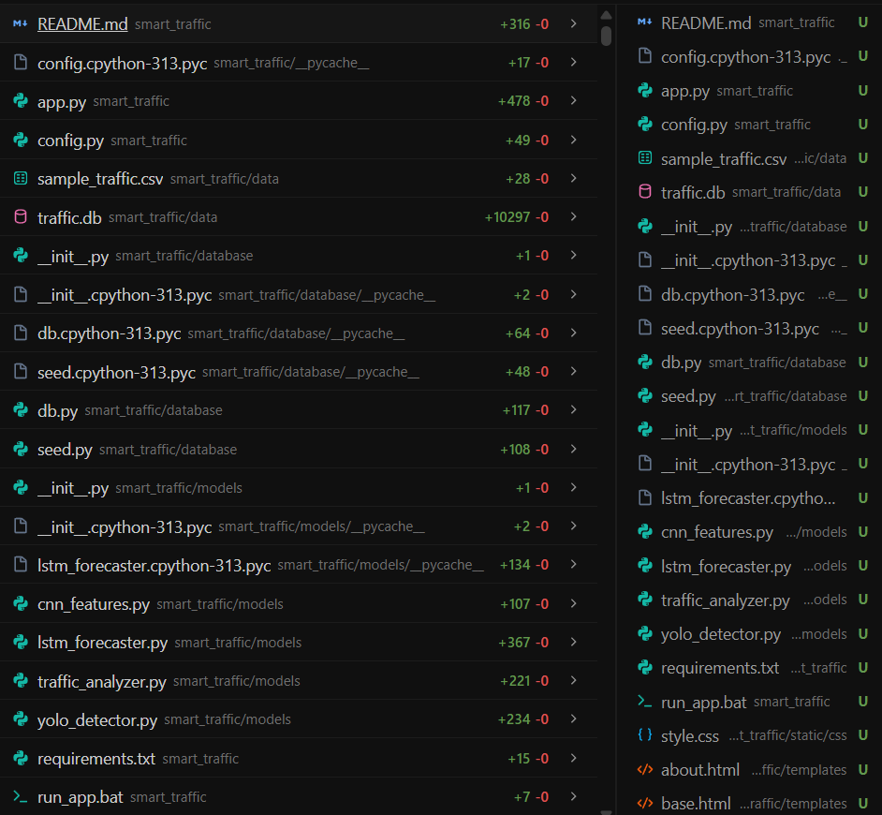
Figure 1:

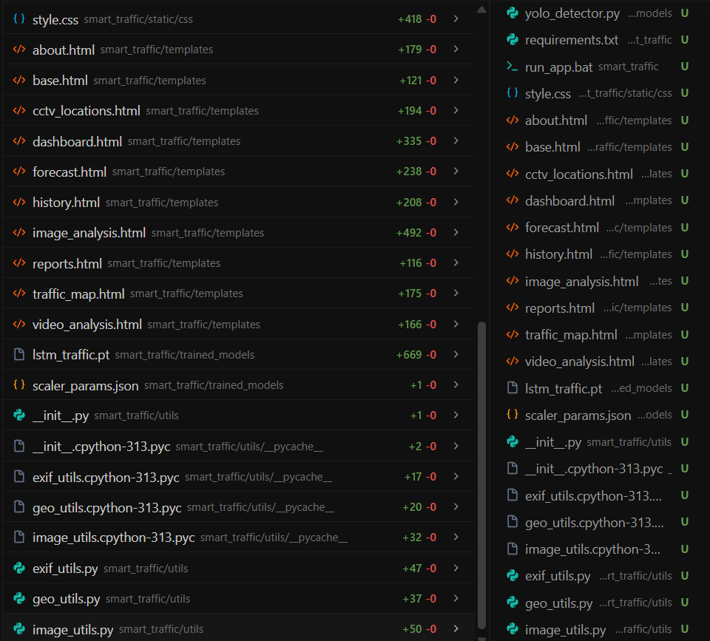
Figure 2:
Appendix B: Algorithms Source files:
Code 1: CNN_Features.py
"""
models/cnn_features.py
CNN-based spatial feature extractor using PyTorch (torchvision).
Role in the pipeline:
YOLO -> Vehicle detection & bounding boxes
CNN -> Spatial feature representation (vehicle distribution, concentration,
occupancy patterns)
LSTM -> Temporal forecasting using the CNN features + counts
We use a lightweight MobileNetV2 backbone (pretrained on ImageNet) to extract
a 1280-dimensional feature vector from the traffic image.
"""
import os
import numpy as np
try:
import torch
import torchvision.models as models
import torchvision.transforms as transforms
from PIL import Image
TORCH_AVAILABLE = True
except Exception:
TORCH_AVAILABLE = False
_cnn_model = None
def _load_cnn():
global _cnn_model
if _cnn_model is None and TORCH_AVAILABLE:
base = models.mobilenet_v2(weights='DEFAULT')
# Remove final classifier — keep features only
base.classifier = torch.nn.Identity()
base.eval()
_cnn_model = base
return _cnn_model
_transform = None
def _get_transform():
global _transform
if _transform is None and TORCH_AVAILABLE:
_transform = transforms.Compose([
transforms.Resize((224, 224)),
transforms.ToTensor(),
transforms.Normalize(mean=[0.485, 0.456, 0.406],
std=[0.229, 0.224, 0.225]),
])
return _transform
def extract_features(image_path: str) -> list:
"""
Extract a 1280-dim feature vector from the input image using MobileNetV2.
Returns a Python list of floats (JSON-serializable).
Returns an empty list if PyTorch is unavailable.

Code 2: LSTM_forecaster.py:
"""
models/lstm_forecaster.py
Location-aware LSTM traffic forecasting using PyTorch.

Architecture:
Input : sequence of (vehicle_count, density, hour, day_of_week)
length = SEQUENCE_LENGTH observations (5-min intervals)
LSTM : 2 stacked LSTM layers (64 units each)
Output: next N steps (vehicle_count, density)

The model is trained per-camera or on all cameras together.
If < SEQUENCE_LENGTH observations exist for a location, the forecast
returns a clear "unavailable" message rather than fabricating predictions.
"""
import os
import json
import numpy as np
from datetime import datetime, timedelta

try:
import torch
import torch.nn as nn
from torch.utils.data import DataLoader, TensorDataset
TORCH_AVAILABLE = True
except Exception:
TORCH_AVAILABLE = False
print("[LSTM] PyTorch not available — forecasting disabled.")

from config import Config

SEQ_LEN = Config.LSTM_SEQUENCE_LENGTH # 10 steps = 50 minutes of history
FEATURES = ['vehicle_count', 'density', 'hour', 'day_of_week']
N_FEATURES = len(FEATURES)
FORECAST_STEPS = [5, 10, 15] # minutes ahead

_lstm_model = None
_scaler_params = None

# ── PyTorch LSTM Model ────────────────────────────────────────────────────────

class TrafficLSTM(nn.Module):
"""Stacked LSTM for traffic density and vehicle count forecasting."""

def __init__(self, input_size=N_FEATURES, hidden_size=64, num_layers=2, output_size=2):
super().__init__()
self.lstm = nn.LSTM(input_size, hidden_size, num_layers,
batch_first=True, dropout=0.2)
self.fc = nn.Linear(hidden_size, output_size)

def forward(self, x):
# x shape: (batch, seq_len, features)
out, _ = self.lstm(x)
out = self.fc(out[:, -1, :]) # last time-step
return out

def build_model():
"""Build the LSTM model."""
if not TORCH_AVAILABLE:
return None
return TrafficLSTM()

def train_lstm(app):
"""
Train the LSTM on all available historical observations.
Called during app startup if model file does not exist.
"""
if not TORCH_AVAILABLE:
print("[LSTM] PyTorch not available — skipping training.")
return

from database.db import Observation
with app.app_context():
rows = Observation.query.order_by(Observation.timestamp).all()
if len(rows) < SEQ_LEN + 1:
print("[LSTM] Not enough data to train.")
return

data = _observations_to_array(rows)
data_norm, params = _normalise(data)
_save_scaler(params)

X, y = _make_sequences(data_norm)
if len(X) == 0:
print("[LSTM] Could not form training sequences.")
return

split = int(len(X) * 0.8)
X_train, X_val = X[:split], X[split:]
y_train, y_val = y[:split], y[split:]

# Convert to tensors
X_train_t = torch.FloatTensor(X_train)
y_train_t = torch.FloatTensor(y_train)
X_val_t = torch.FloatTensor(X_val)
y_val_t = torch.FloatTensor(y_val)

train_ds = TensorDataset(X_train_t, y_train_t)
train_dl = DataLoader(train_ds, batch_size=32, shuffle=True)

model = build_model()
optimizer = torch.optim.Adam(model.parameters(), lr=0.001)
criterion = nn.MSELoss()

best_val_loss = float('inf')
patience_counter = 0
max_patience = 8

model.train()
for epoch in range(Config.LSTM_EPOCHS):
epoch_loss = 0.0
for xb, yb in train_dl:
optimizer.zero_grad()
pred = model(xb)
loss = criterion(pred, yb)
loss.backward()
optimizer.step()
epoch_loss += loss.item()

# Validation
model.eval()
with torch.no_grad():
val_pred = model(X_val_t)
val_loss = criterion(val_pred, y_val_t).item()
model.train()

if val_loss < best_val_loss:
best_val_loss = val_loss
patience_counter = 0
# Save best model
os.makedirs(Config.TRAINED_MODELS_DIR, exist_ok=True)
torch.save(model.state_dict(), Config.LSTM_MODEL_PATH)
else:
patience_counter += 1
if patience_counter >= max_patience:
print(f"[LSTM] Early stopping at epoch {epoch+1}")
break

# Load best weights
model.load_state_dict(torch.load(Config.LSTM_MODEL_PATH, weights_only=True))

# Compute validation MAE
model.eval()
with torch.no_grad():
val_pred = model(X_val_t)
val_mae = torch.mean(torch.abs(val_pred - y_val_t)).item()

print(f"[LSTM] Training complete. val_loss={best_val_loss:.4f} val_mae={val_mae:.4f}")
global _lstm_model
_lstm_model = model

def _load_model():
global _lstm_model, _scaler_params
if not TORCH_AVAILABLE:
return None, None
if _lstm_model is None:
if os.path.exists(Config.LSTM_MODEL_PATH):
model = TrafficLSTM()
model.load_state_dict(torch.load(Config.LSTM_MODEL_PATH, weights_only=True))
model.eval()
_lstm_model = model
else:
return None, None
if _scaler_params is None:
_scaler_params = _load_scaler()
return _lstm_model, _scaler_params

def forecast_location(camera_id: str, app) -> dict:
"""
Generate 5/10/15-minute ahead forecasts for a specific camera.

Returns:
{
'available': bool,
'reason': str (if unavailable),
'forecasts': [{'minutes': 5, 'vehicle_count': X, 'density': Y, 'congestion': Z}, ...],
'historical': [...], # last 20 observations for chart
'metrics': {'mae': ..., 'rmse': ...}
}
"""
from database.db import Observation
with app.app_context():
rows = (Observation.query
.filter_by(camera_id=camera_id)
.order_by(Observation.timestamp.desc())
.limit(SEQ_LEN + 50)
.all())
rows = list(reversed(rows))

if len(rows) < SEQ_LEN:
return {
'available': False,
'reason': f'Forecast unavailable — only {len(rows)} observations '
f'exist for this location (minimum required: {SEQ_LEN}).',
'forecasts': [],
'historical': _historical_for_chart(rows),
'metrics': None,
}

model, params = _load_model()
if model is None or params is None:
return {
'available': False,
'reason': 'LSTM model not yet trained. Run the training script first.',
'forecasts': [],
'historical': _historical_for_chart(rows),
'metrics': None,
}

data = _observations_to_array(rows)
data_norm, _ = _normalise(data, params)
seq = data_norm[-SEQ_LEN:] # last SEQ_LEN steps

forecasts = []
current_seq = seq.copy()
last_ts = rows[-1].timestamp

model.eval()
for step_idx, minutes in enumerate(FORECAST_STEPS):
inp = torch.FloatTensor(current_seq).unsqueeze(0) # (1, seq_len, features)
with torch.no_grad():
pred_norm = model(inp).numpy()[0]

# Denormalise vehicle_count and density
vc_pred = _denorm(pred_norm[0], params, 'vehicle_count')
den_pred = _denorm(pred_norm[1], params, 'density')
vc_pred = max(0, round(vc_pred))
den_pred = max(0.0, min(100.0, round(den_pred, 1)))
cong = _congestion_label(den_pred)
pred_ts = last_ts + timedelta(minutes=minutes)

forecasts.append({
'minutes': minutes,
'timestamp': pred_ts.isoformat(),
'vehicle_count': vc_pred,
'density': den_pred,
'congestion': cong,
})

# Slide window
new_row = np.array([
pred_norm[0],
pred_norm[1],
(pred_ts.hour) / 23.0,
(pred_ts.weekday()) / 6.0,
])
current_seq = np.vstack([current_seq[1:], new_row])

return {
'available': True,
'reason': '',
'forecasts': forecasts,
'historical': _historical_for_chart(rows[-20:]),
'metrics': _compute_metrics(model, data_norm, params),
}

def _observations_to_array(rows) -> np.ndarray:
data = []
for r in rows:
ts = r.timestamp
data.append([
r.vehicle_count,
r.density,
ts.hour,
ts.weekday(),
])
return np.array(data, dtype=np.float32)

def _make_sequences(data: np.ndarray):
X, y = [], []
for i in range(len(data) - SEQ_LEN):
X.append(data[i: i + SEQ_LEN])
y.append(data[i + SEQ_LEN, :2]) # vehicle_count, density
return np.array(X), np.array(y)

def _normalise(data: np.ndarray, params: dict = None):
if params is None:
params = {}
for i, col in enumerate(FEATURES):
params[col] = {'min': float(data[:, i].min()), 'max': float(data[:, i].max())}

norm = data.copy()
for i, col in enumerate(FEATURES):
mn, mx = params[col]['min'], params[col]['max']
rng = mx - mn if mx != mn else 1.0
norm[:, i] = (data[:, i] - mn) / rng
return norm, params

def _denorm(val: float, params: dict, col: str) -> float:
mn, mx = params[col]['min'], params[col]['max']
return val * (mx - mn) + mn

def _scaler_path():
return os.path.join(Config.TRAINED_MODELS_DIR, 'scaler_params.json')

def _save_scaler(params: dict):
os.makedirs(Config.TRAINED_MODELS_DIR, exist_ok=True)
with open(_scaler_path(), 'w') as f:
json.dump(params, f)

def _load_scaler() -> dict:
p = _scaler_path()
if os.path.exists(p):
with open(p) as f:
return json.load(f)
return None

def _congestion_label(density: float) -> str:
if density <= 25: return 'LOW'
if density <= 50: return 'MODERATE'
if density <= 75: return 'HIGH'
return 'SEVERE'

def _historical_for_chart(rows) -> list:
return [{
'timestamp': r.timestamp.isoformat() if r.timestamp else None,
'vehicle_count': r.vehicle_count,
'density': r.density,
'congestion': r.congestion_level,
} for r in rows]

def _compute_metrics(model, data_norm: np.ndarray, params: dict) -> dict:
"""Compute MAE and RMSE on held-out validation portion."""
if not TORCH_AVAILABLE:
return {'mae': None, 'rmse': None, 'accuracy': None}
if len(data_norm) < SEQ_LEN + 5:
return {'mae': None, 'rmse': None, 'accuracy': None}

X, y_true = _make_sequences(data_norm)
split = max(1, int(len(X) * 0.8))
X_val, y_val_norm = X[split:], y_true[split:]
if len(X_val) == 0:
return {'mae': None, 'rmse': None, 'accuracy': None}

model.eval()
with torch.no_grad():
y_pred_norm = model(torch.FloatTensor(X_val)).numpy()

# Denorm vehicle_count
vc_min, vc_max = params['vehicle_count']['min'], params['vehicle_count']['max']
vc_rng = vc_max - vc_min if vc_max != vc_min else 1.0
y_true_vc = y_val_norm[:, 0] * vc_rng + vc_min
y_pred_vc = y_pred_norm[:, 0] * vc_rng + vc_min

mae = float(np.mean(np.abs(y_true_vc - y_pred_vc)))
rmse = float(np.sqrt(np.mean((y_true_vc - y_pred_vc) ** 2)))
accuracy = max(0.0, 100.0 - (rmse / max(1, y_true_vc.mean()) * 100))

return {
'mae': round(mae, 2),
'rmse': round(rmse, 2),
'accuracy': round(accuracy, 2),
}

Appendix C: Engineering Standards Mapping
Standard / Practice | Area Applied | How It Was Applied in This Project
IEEE 1012 (Verification & Validation, style) | Model evaluation | Held-out test data used with RMSE, accuracy, precision, and recall metrics rather than informal inspection.
Modular / separation-of-concerns design | System architecture | Detection, feature extraction, forecasting, and visualisation implemented as independent modules.
Reproducible ML experimentation practice | Development workflow | Fixed train/test splits and documented, version-controlled code for repeatable results.
Data-quality / pre-processing best practice | Data pipeline | Consistent frame resizing, normalisation, and noise removal prior to model input.
Table 5: Mapping of engineering and industry standards applied to the project.

